**Choosing Appropriate Statistical Analyses**

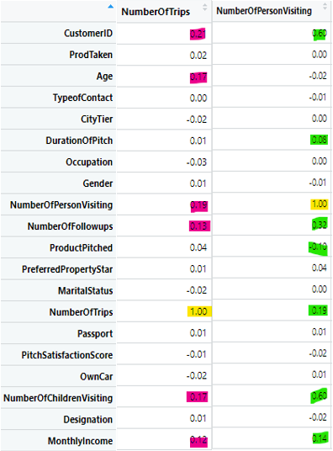##Matrix Correlation observation:

#DVs: NumberOfTrips and NumberOfPersonVisiting

## correlated with each other 0.19

IVs correlated with both DVs:

NumberofFollowups

Monthly Income

NumberofChildrenVisiting

IVs correlated with NumberofTrips only:

1. Age

IVs correlated with NumberOfPersonVisiting only:

ProductPitched: negative correlation

DurationOfPitch

Exam variables means:

1. NumberofFollowups

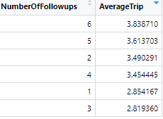 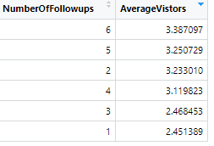

Customers who receive 1 and 3 follow ups on average make less trips and less number of vistors.

Note that customers who receive 2 follow ups on average ranking 3rd in average number of trips and visitors.

1. 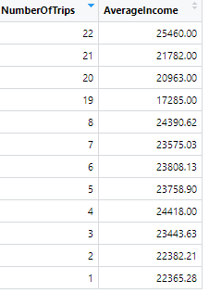Monthly Income:

* Customer with the highest average monthly income makes the most trips on average.
* However, customer with the lowest average monthly income of 17285 only rank 4th with 19 trips on average. Good potential customer target groups to

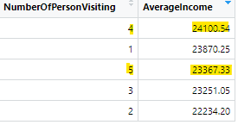

* Worth noticing here is the group with most visitors rank 3rd in monthly income.
* Second by the highest group in monthly income.

1. NumberofChildrenVisiting:

* 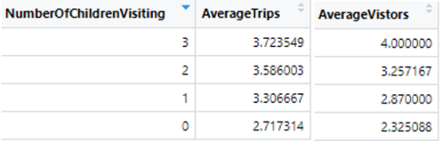The higher number of children visiting, the higher average Trips and Visitors.
* Having children along is a strong indicator for customers to take trips.

1. 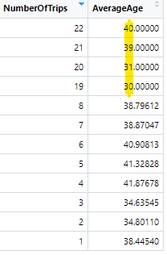 Age and number of Trips

* People who are 39 to 40 have the highest number of trips, second by 30 to 31 age group.
* Notice customer of 41 years of age make only 4 to 5 trips.

1. Duration of Pitched and Number of People Visiting:

* 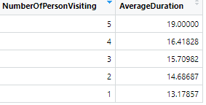The longer the pitch duration the more visitors per trips.

1. 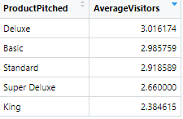Product Pitched and Number of People Visiting:

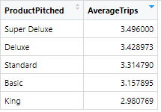

* Deluxe has the highest average visitors.
* Super Deluxe has 2nd to the lowest number of visitors but the most average number of trips.
* King has the lowest average visitors and number of trips.

Product Pitch Conversion Coding:

Basic: 1

Deluxe: 2

King:3

Standard: 4

Super Deluxe:5